**WHAT CAUSES WILDFIRES: A STUDY TO IMPROVE THE EXPENDITURE ON WILDFIRES**

**Xi Zhang**

**11/3/2020**

**Abstract**

In this research paper, I evaluated the relationship between the area burned by wildfires and human/fuel aridity factors. Using the data collected from the past three decades, the regression statistics demonstrate that the areas burnt by wildfires have little correlation to any human factors, including the numbers of housing units, government spending, and college attainment. Nonetheless, at the end of the paper, I showed with the regression result that fuel aridity had a linear relationship with the burned area by wildfire. Ultimately, the regression suggests that the current wildland fire management budget is omitting the importance of fuel aridity which needs better management, including but not limited to increased funding.

**Introduction**

Wildfire has always been a problem in the United States. Each year the government spends millions of dollars fighting the wildfires and the budget only increases every year. Even though the United States government has been putting tremendous amounts of dollars and human effort towards the prevention and eradication of the fires, the wildfires have still cost trillions of dollars of damage each year for many decades past. It has become a global concern wherein millions of acres of forests were incinerated, followed by thousands of people losing their homes and countless numbers of species losing their natural habitat.

While we are suffering this ongoing pandemic, what everyone hopes to see is that the wildfire problem would be decreasing given the continued pouring of government resources towards solving the problem; this is unfortunately not the case given current statistics. The goal of this research is to elucidate what is causing the wildfires by using the regression model, then use the result from our regression to evaluate the current wildland fire management budget and improve it. In order to understand better ways to deal with wildfires, we need to find out their origins and the environments in which they thrive. The two major branches that have a positive linear relationship with wildfires that we are using in this research are: human and fuel aridity. An idea of the wildland-urban interface (WUI) was introduced in the article ***Rapid growth of the US wildland-urban interface raises wildfire risk***. WUI stands for the area where houses and wildland vegetation meet and based on the study, that is where most wildfires occurred. The rapid growth of WUI and wildfires is leading to the conclusion that humans are the most important factor of the wildfire theoretically and statistically. Another article called ***Impact of anthropogenic climate change on wildfire across western US forests*** showed us that human-caused climate change caused more than half of fuel aridity on record. Furthermore, the author’s analysis shows that human-caused climate changes will continue to increase in the long term.

The aforementioned two terms: human and fuel aridity will be directly used to build our model. As we know what matters are of the utmost significance with regards to wildfires’ causal factors, government expenditure would do well to apply the results from the regression.

**Literature review**

The previous literature has provided us the methodology used in terms of evaluating the burned area by wildfires, as well as human and fuel aridity being the two major reasons for wildfire. With regards to human factors, Radeloff stated in his article that climate change forecasts indicate wildfires will occur more frequently in the future. Therefore, due to the expansion of the WUI, more urban environments will be susceptible to the spreading of fire, leading to more expansive fires. This indicates that WUI growth and climate change will coalesce towards the existing problem with wildfires related to WUI. The author gave us an important message that the housing units, population, and WUI area would be the vital factors that are causing wildfires. Since the 1970s, human-caused temperature increases and insufficient vapor pressure has increased the fuel aridity throughout the western forests in the United States. The author used multiple linear models to emphasize that the increase in human-caused fuel aridity has caused a tremendous increase in forest area burned each year. The models include annual western continental United States forest fire area in correlation with fuel aridity. Standardized change in each of the eight fuel aridity metrics due to anthropogenic climate change, and the evolution and trends in western US forest fuel aridity metrics over the past several decades. When putting all the models together, the result demonstrates a positive linear relationship.

Since one of our most important goals as a society is to find the optimal solution to the wildfire problem, the expenditure model is vital in conducting this research. In the book *Economics of Wildfire Management,* the author examined existing approaches for modeling the determinants and consequences of wildfire management activities and extended on management costs, models of wildfire suppression expenditures, and the application of empirical results. The author left out at the end of the book saying that they are much more to learn about many variables such as risk or cost of management to further discuss. However, the author did provide the examination of previous “optimal” expenditure models which helped my research on finding which are the important expenditure objects.

***Rapid growth of the US wildland-urban interface raises wildfire risk***(Radeloff et al, 2017)

The first piece of evidence we wish to find is human factors and this article is focusing on how the wildland-urban interface (WUI) caused a rapid increase in wildfires in the past 3 decades. The conclusion that the author proposed was that humans are a critical component of wildfire in terms of changing the climate and WUI. The idea of WUI was novel from the time of this article’s introduction given that it introduced a new area when thinking about the cause of wildfires. These are areas that previous articles had seldom discussed. There are two main reasons which the author introduced. First, there will be more wildfires due to human pollution. Second, wildfires that occur will pose a greater risk to lives and homes will be difficult to fight. The author proved that by showing the stats that the WUI has a positive linear relationship with areas ravaged by wildfires.

Dr. Radeloff also has shown that humans were the vital reason for wildfires as well as the spread to houses and urban areas, whereas in this article, the author summarized them and combined them together with WUI. Thus, human interference would be a substantial portion of our regression model due to the fact that Dr. Radeloffa pointed. But, it won’t explain everything about wildfires; we would need to know about other contributing factors such as climate.

***Impact of anthropogenic climate change on wildfire across western US forests***

In this article (Abatzogloua, John, and Williams, Park, 2016), Abatzogloua and Williams focused on answering how anthropogenic climate change impacts wildfire. The answer given is that anthropogenic increases in temperature and a vapor pressure deficit significantly increased fuel aridity across western US forests, which leads to more wildfires. This study focused more on fuel aridity where the author leads directly to human causations compared to the previous studies. Also, the conclusion is fairly the same compared to the previous studies that anthropogenic climate change is causing wildfires. The logic provided by the author is that climatic conditions are more conducive to wildfire. Followed by the empirical study that the data of fuel aridity and burned areas showed a linear relationship. The author also assumed that anthropogenic increases in fuel aridity are additive to the extents of wildfires which are borne of natural climate variability.

The author provided many data comparisons on fuel aridity and forest fires, in which all of them demonstrate a positive linear relationship. Since the article is scientific in origin, the author gave detailed theoretical and empirical analysis to explain and answer the hypothesis. This article gave us another piece of information that fuel aridity is what we are looking for in terms of causing wildfire associated with human interaction.

***Economics of Wildfire Management: The Development and Application of Suppression Expenditure Models***

As the last piece of my research, combining the regression results from wildfire with the wildland fire management budget would be the last step. Nonetheless, Dr. Hand has given us some directions on what to do. In this book, Dr. Hand examined the current suppressing expenditure model and the goal was to find a more cost-effective expenditure model for decision making by thinking about a question: What have we learned thus far about the costs of managing wildfires in the United States, and how has this knowledge been used in a management and policy context(Hand, Michael et al, 2017)? The answer that the author proposed was that there’s much remains to be known about the costs of fire management to find the optimal expenditure. In each of the first five chapters in the book, the author tested many expenditure models from previous studies and explained the application of them. On top of that, the author also talked about the gaps that remained unknown about wildfire management costs and expenditures.

This study gave us many pieces of information since the study upon what has been studied is the right way and the variable in chapter five also makes logical sense. Thus in my research, I intend to fill the gap between the three pieces of information and use the regression to improve the current expenditure budget.

**Empirical Framework**

* Empirical Methodology

Based on previous literature, the regression model has been derived from models like suppression expenditures on a large wildland fire spent model (Liang et al. 2008). It used ordinary least squares regressions of total USFS expenditures on the specific landscape characteristics and some other factors. Also, the Rocky Mountain Research Station developed models to predict expenditures on individual large wildland fires. This model is useful for understanding how different environments and economic characteristics change wildland fire expenditures. Both models link all the different factors with expenditure. My model used a very similar method with the research of regional and temporal patterns of wildfire suppression expenditures(Hand, Michael et al, 2014, Economics of Wildfire Management, New York, pg 19-25). The key of the model by Hand is that he tested the expenditure model on different regions to see if it matters with regional data. In addition to the previous studies, I used a similar factor-based fix effect model with both environmental and economic factors to study the Natural log of acres burned area. This allows me to find the problem directly from the wildfire itself, and with the fixed effect we would be able to avoid omitted variable bias given preexisting state and year as dummy variables across 3 years with 50 different states. My regression model can be written as:

Specifically, as I have mentioned, I used the combination of economic factors and environmental factors to measure what factors have a linear relationship with the burned area by wildfire. My hypothesis is that acres of forest burned by wildfires will have strong linear relationships with human factor variables such as college attainment, government spending, and population. It should also have some linear relationship with fuel aridity variables such as rain, temperature, and humidity.

* Data and Descriptive Statistics

Since the previous studies have shown all the vital factors that cause the rapid growth of wildfires, this research paper focuses primarily on determining the linear relationship between wildfires and each of the RHS variables. Then combine the statistical relationships with the expenditure budget in terms of which variables should the government put more budget on to improve the expenditure model. This research combined the idea of using the 3-year panel data (the year 2000, 2010, 2019) to estimate the linear relationship between burned areas and human/climate factors.

In terms of regression analysis, I used the natural log form burned forest area in acres as my RHS variable, shared with the National Interagency Coordination Center in 2019, 2010, and 2000. I included each of the fifty states as my observations. For each state, I choose to use three years (2000, 2010, 2019) worth of data due to variable change across many decades. Since the previous study has shown that 84% of wildfires are caused by humans, I used numbers of fire departments (U.S. Fire Administration/National Fire Data Center, 2014), government spendings (State and local finance Initiative) on fire management each year, and college attainment in each state as my RHS variables to explain if any policies and human interaction were a factor in the areas burned from wildfire. Since the wildfire naturally consists of climate variables, we are going to include average rain level, average temperature, number of lakes, numbers of wildfires, and average annual percentage humidity all as my nature-related RHS variables. Table 1 shows the collection of data towards my regression model.

Table.1 Variables

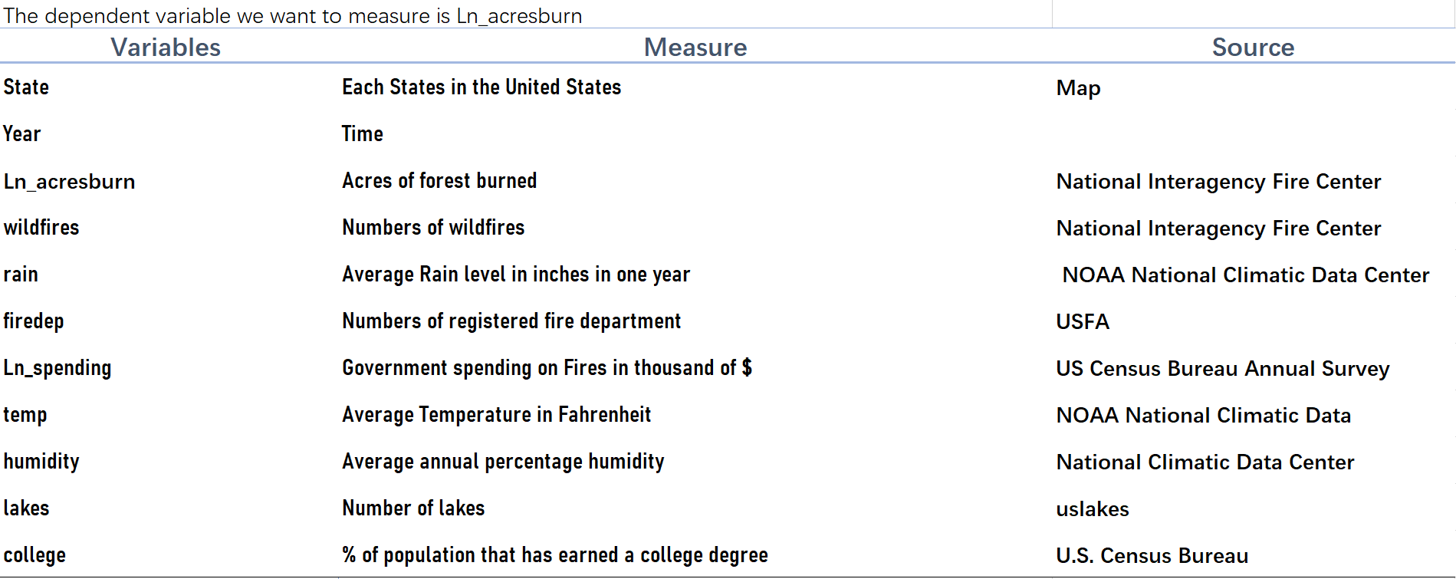

The data appendix yields the specific dataset for the entire regression.

**Regression Result**

We started the research with a question about what caused wildfires. It is evident that the acres burned area includes several outliers (as Table 5 has shown) which infers that burned areas should have significant differences across different states. As the descriptive statistics table indicated that the mean for acres burned is roughly 100,000 but the standard deviation is about 300,000. So the acres burned would differ across different states from 0 to 2.4 million acres and super skewed. Such inconsistencies might cause many problems when we run the regression.

Table 5 Descriptive statistics

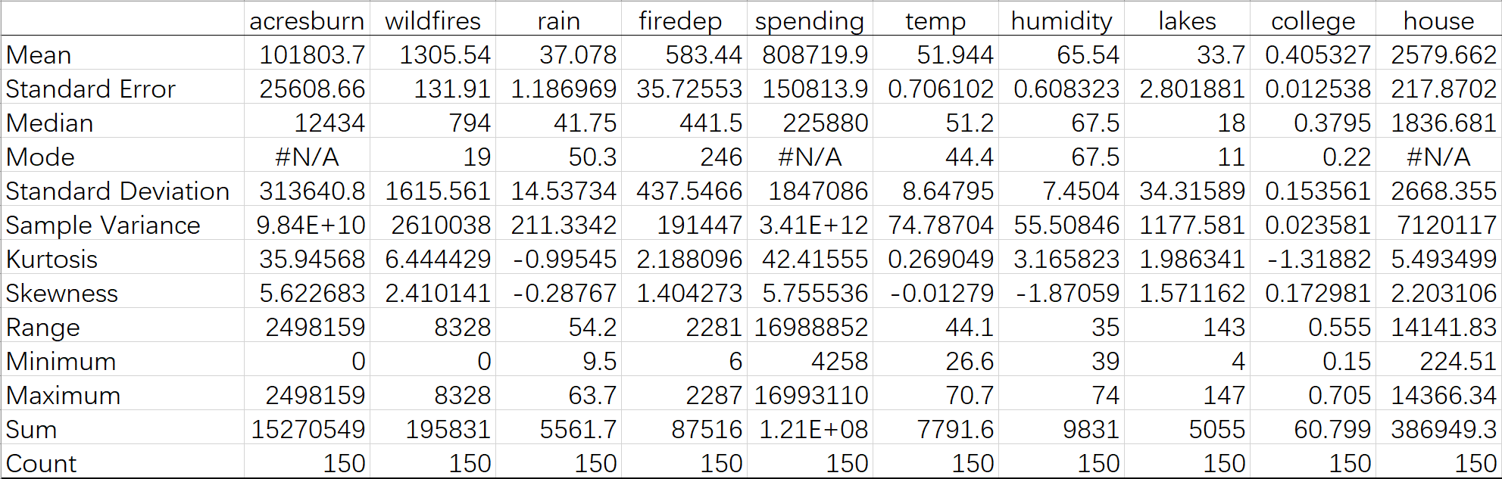

The assumption we made at the beginning of the research was that acres of forest burned by wildfires will have strong linear relationships with human factor variables including college attainment, numbers of fire departments, government spending, and population. Nonetheless, it should also have some linear relationship with fuel aridity variables including rain, temperature, and humidity. From the regression results in table 2 with an adj_R^2 of 0.8867, our regression model does explain the marked 89% of the change in burned areas. Surprisingly, as we dig more into the result, we can see that the fire department, government spending, and college attainment was not significant at the 0.05 alpha level. Even though the government spending variable was not significant, we could still suppose that there should exist some reverse causality since more wildfires would force the government to put more funds towards fire suppression. Fortunately, most of the climate variables were significant including wildfires, rain, temperature, and humidity. Additionally, we found out was that different states will have some different coefficients on the burned areas, which implies that being in different states would influence the burning area.

Table 2.A Regression Result

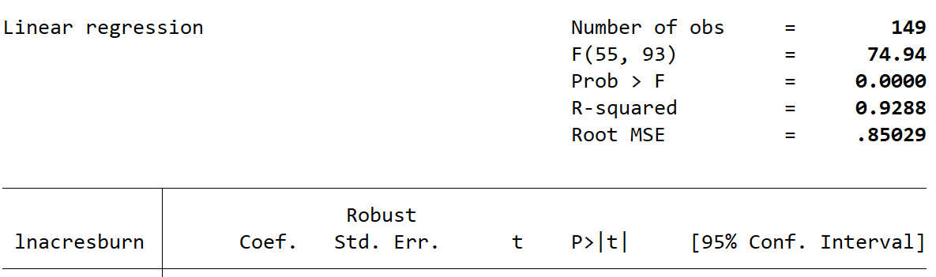

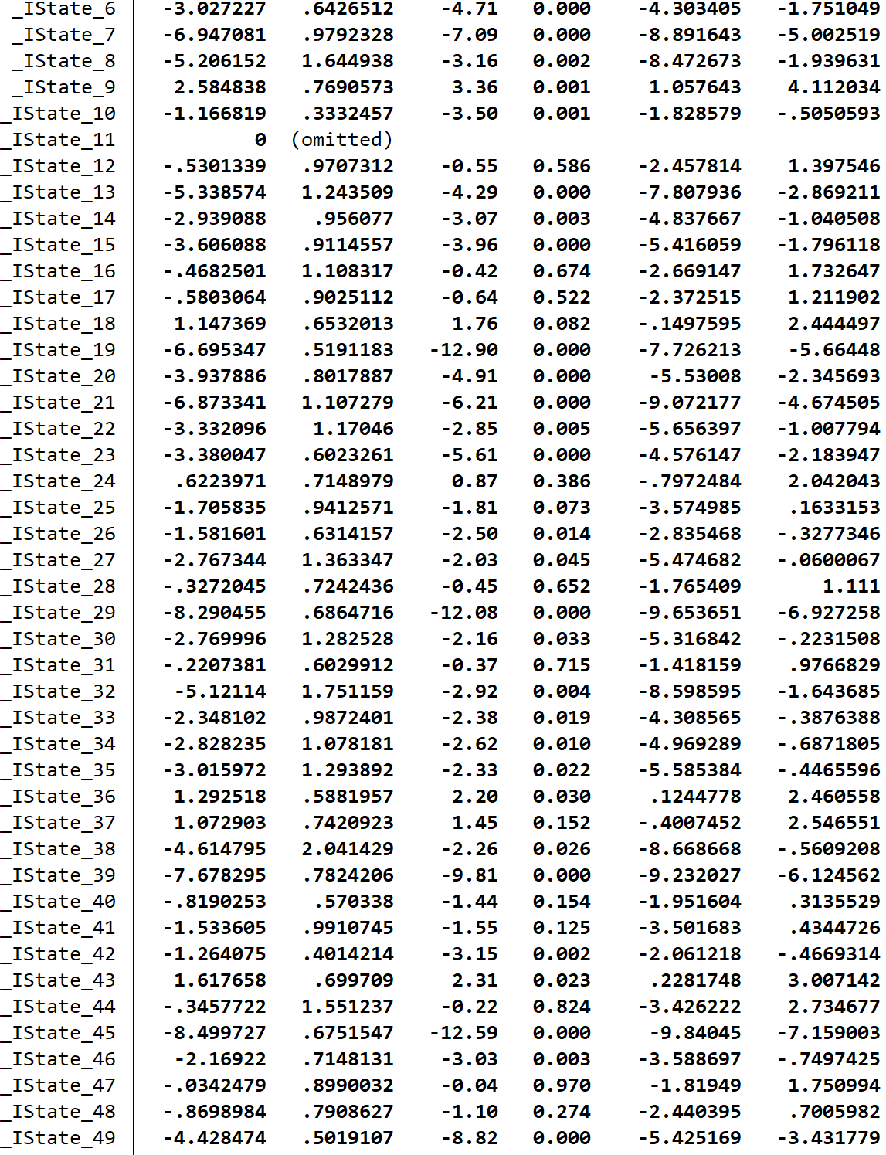

Table 2.B Regression Result

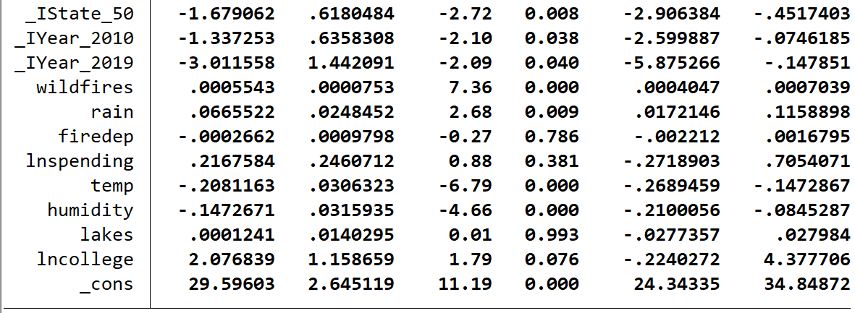

If we specifically look at the rain variable in Table 2.B, we are able to see that a one-inch increase in rain level is associated with a 6.6% increase in the burned area. This was an unexpected result because normally when it rains more, forests have relatively lower chances of catching wildfires. The coefficient of variable temperature shows us that a one-degree Ferengi increase is associated with a 20.8% decrease in the area burned. Also, humidity gives us the information its increase implies a decrease in the area burned.

**Conclusion**

From the evidence in variables including the numbers of the fire department, government spending, and college attainment we are able to conclude from our regression results that the burned area by wildfire does not necessarily have any linear relationship with human interference. In contrast, fuel aridity did have a linear relationship with acres burned by wildfire. Specifically, Table 2.B shows that more numbers of wildfires will cause larger burned areas, more inches of rain level will cause more wildfires, a higher temperature will cause less burned areas, and higher humidity will cause less burned areas. Thus fuel management is important in terms of budgeting wildfire expenditures. As Table 3 (The United States Department of the Interior, 2020) showed, current fuel management is only 20% of all the expenditure on wildland fire management. Even though fire suppression and preparation are certainly important as the damage from the wildfire needed to be taken care of, the result of this research indicated that climate/fuel aridity is highly correlated with the burned area. The research would suggest that the budget for fuel management should be concerned as a core of managing the wildfire problems. Also, as Table 6 illustrates, when we add all the variables one by one, the adjusted R square either remains constant or decreased except for variable numbers of wildfires and the dummy variables.

Table 3 Current Wildfire Budget summary

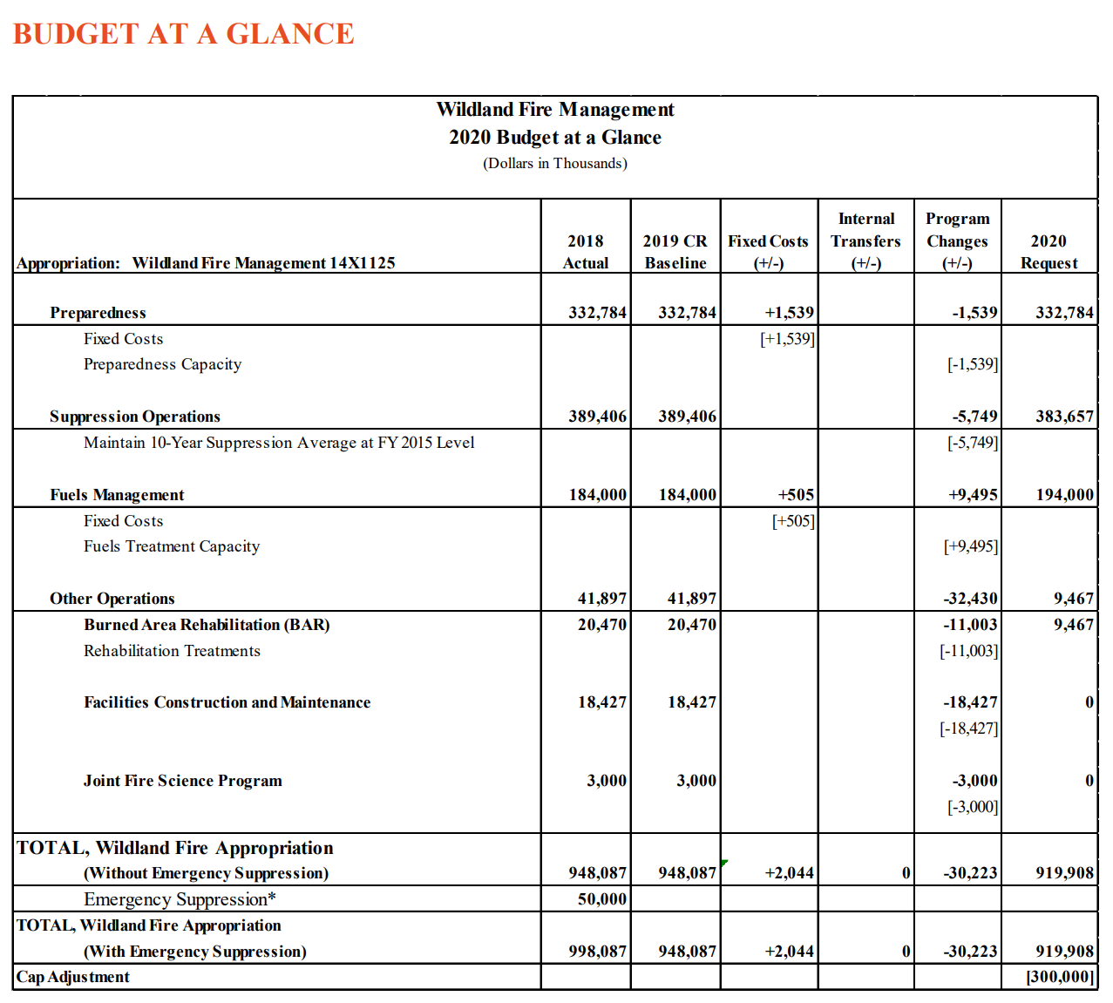

With the information provided from our regression result, one explanation we may suppose is that even though rain level will affect the fuel aridity, more rain can also result in vegetation to grow significantly. Especially in a place like California where the vegetations adapt to the desert weather and will be more sensitive to the water supply.

In addition, since acres burned by wildfire differ year to year and across different states, more data should be collected in order to have more accurate estimates. In order to avoid outliers of “heavy” wildfire years, it would be better to include data from every year across three decades. Also, it would be much helpful for this research if there were no difficulties in collecting data in detail expenditure summary.

Reference

1. Abatzogloua, John, and Williams, Park, 2016, “Impact of anthropogenic climate change on wildfire across western US forests”, University of Idaho, Columbia University, <https://www.pnas.org/content/pnas/113/42/11770.full.pdf>
2. Hand, Michael et al, 2014, Economics of Wildfire Management, New York, pg 32
3. National interagency coordination center, 2010, “National Report of Wildland Fires and Acres Burned by State”, pg 13, <https://www.predictiveservices.nifc.gov/intelligence/2010_statssumm/fires_acres.pdf>
4. National interagency coordination center, 2019, “National Report of Wildland Fires and Acres Burned by State”, <https://www.predictiveservices.nifc.gov/intelligence/2019_statssumm/fires_acres19.pdf>
5. National interagency coordination center, 2000, “National Report of Wildland Fires and Acres Burned by State”, <https://www.predictiveservices.nifc.gov/intelligence/2002_statssumm/fires_acres.pdf>
6. State and local finance Initiative, “[Census of Governments and its associated annual survey](https://www.census.gov/programs-surveys/gov-finances.html)”, <https://state-local-finance-data.taxpolicycenter.org/pages.cfm>
7. The United States Department of the Interior, 2020, “BUDGET JUSTIFICATIONS WILDLAND FIRE MANAGEMENT”, <https://www.doi.gov/sites/doi.gov/files/uploads/fy_2020_wildland_fire_management_budget_justification_for_posting.pdf>
8. U.S. Fire Administration/National Fire Data Center, 2014, “Data Sources and Methodology Documentation”, pg 4-5, <https://www.usfa.fema.gov/downloads/pdf/statistics/data_sources_methodology.pdf>
9. U.S. Census Bureau, 2016, “Housing Units Intercensal Tables: 2000-2010”, <https://www.census.gov/data/tables/time-series/demo/popest/intercensal-2000-2010-housing-units.html>
10. U.S. Census Bureau, 2020, “National, State, and County Housing Unit Totals: 2010-2019”, <https://www.census.gov/data/tables/time-series/demo/popest/2010s-total-housing-units.html>
11. U.S. Census Bureau, 2019, “State population totals and components of change:2010-2019”, <https://www.census.gov/data/tables/time-series/demo/popest/2010s-state-total.html>
12. U.S. Census Bureau, 2016, “State intercensal tables:2000-2010”, <https://www.census.gov/data/tables/time-series/demo/popest/intercensal-2000-2010-state.html>
13. Volker C. Radeloff el al, 2017, “Rapid growth of the US wildland-urban interface raises wildfire risk”, SILVIS Lab, Vol 115, <https://www.pnas.org/content/pnas/115/13/3314.full.pdf>

Table 4.A Data Appendix Data for the year 2019

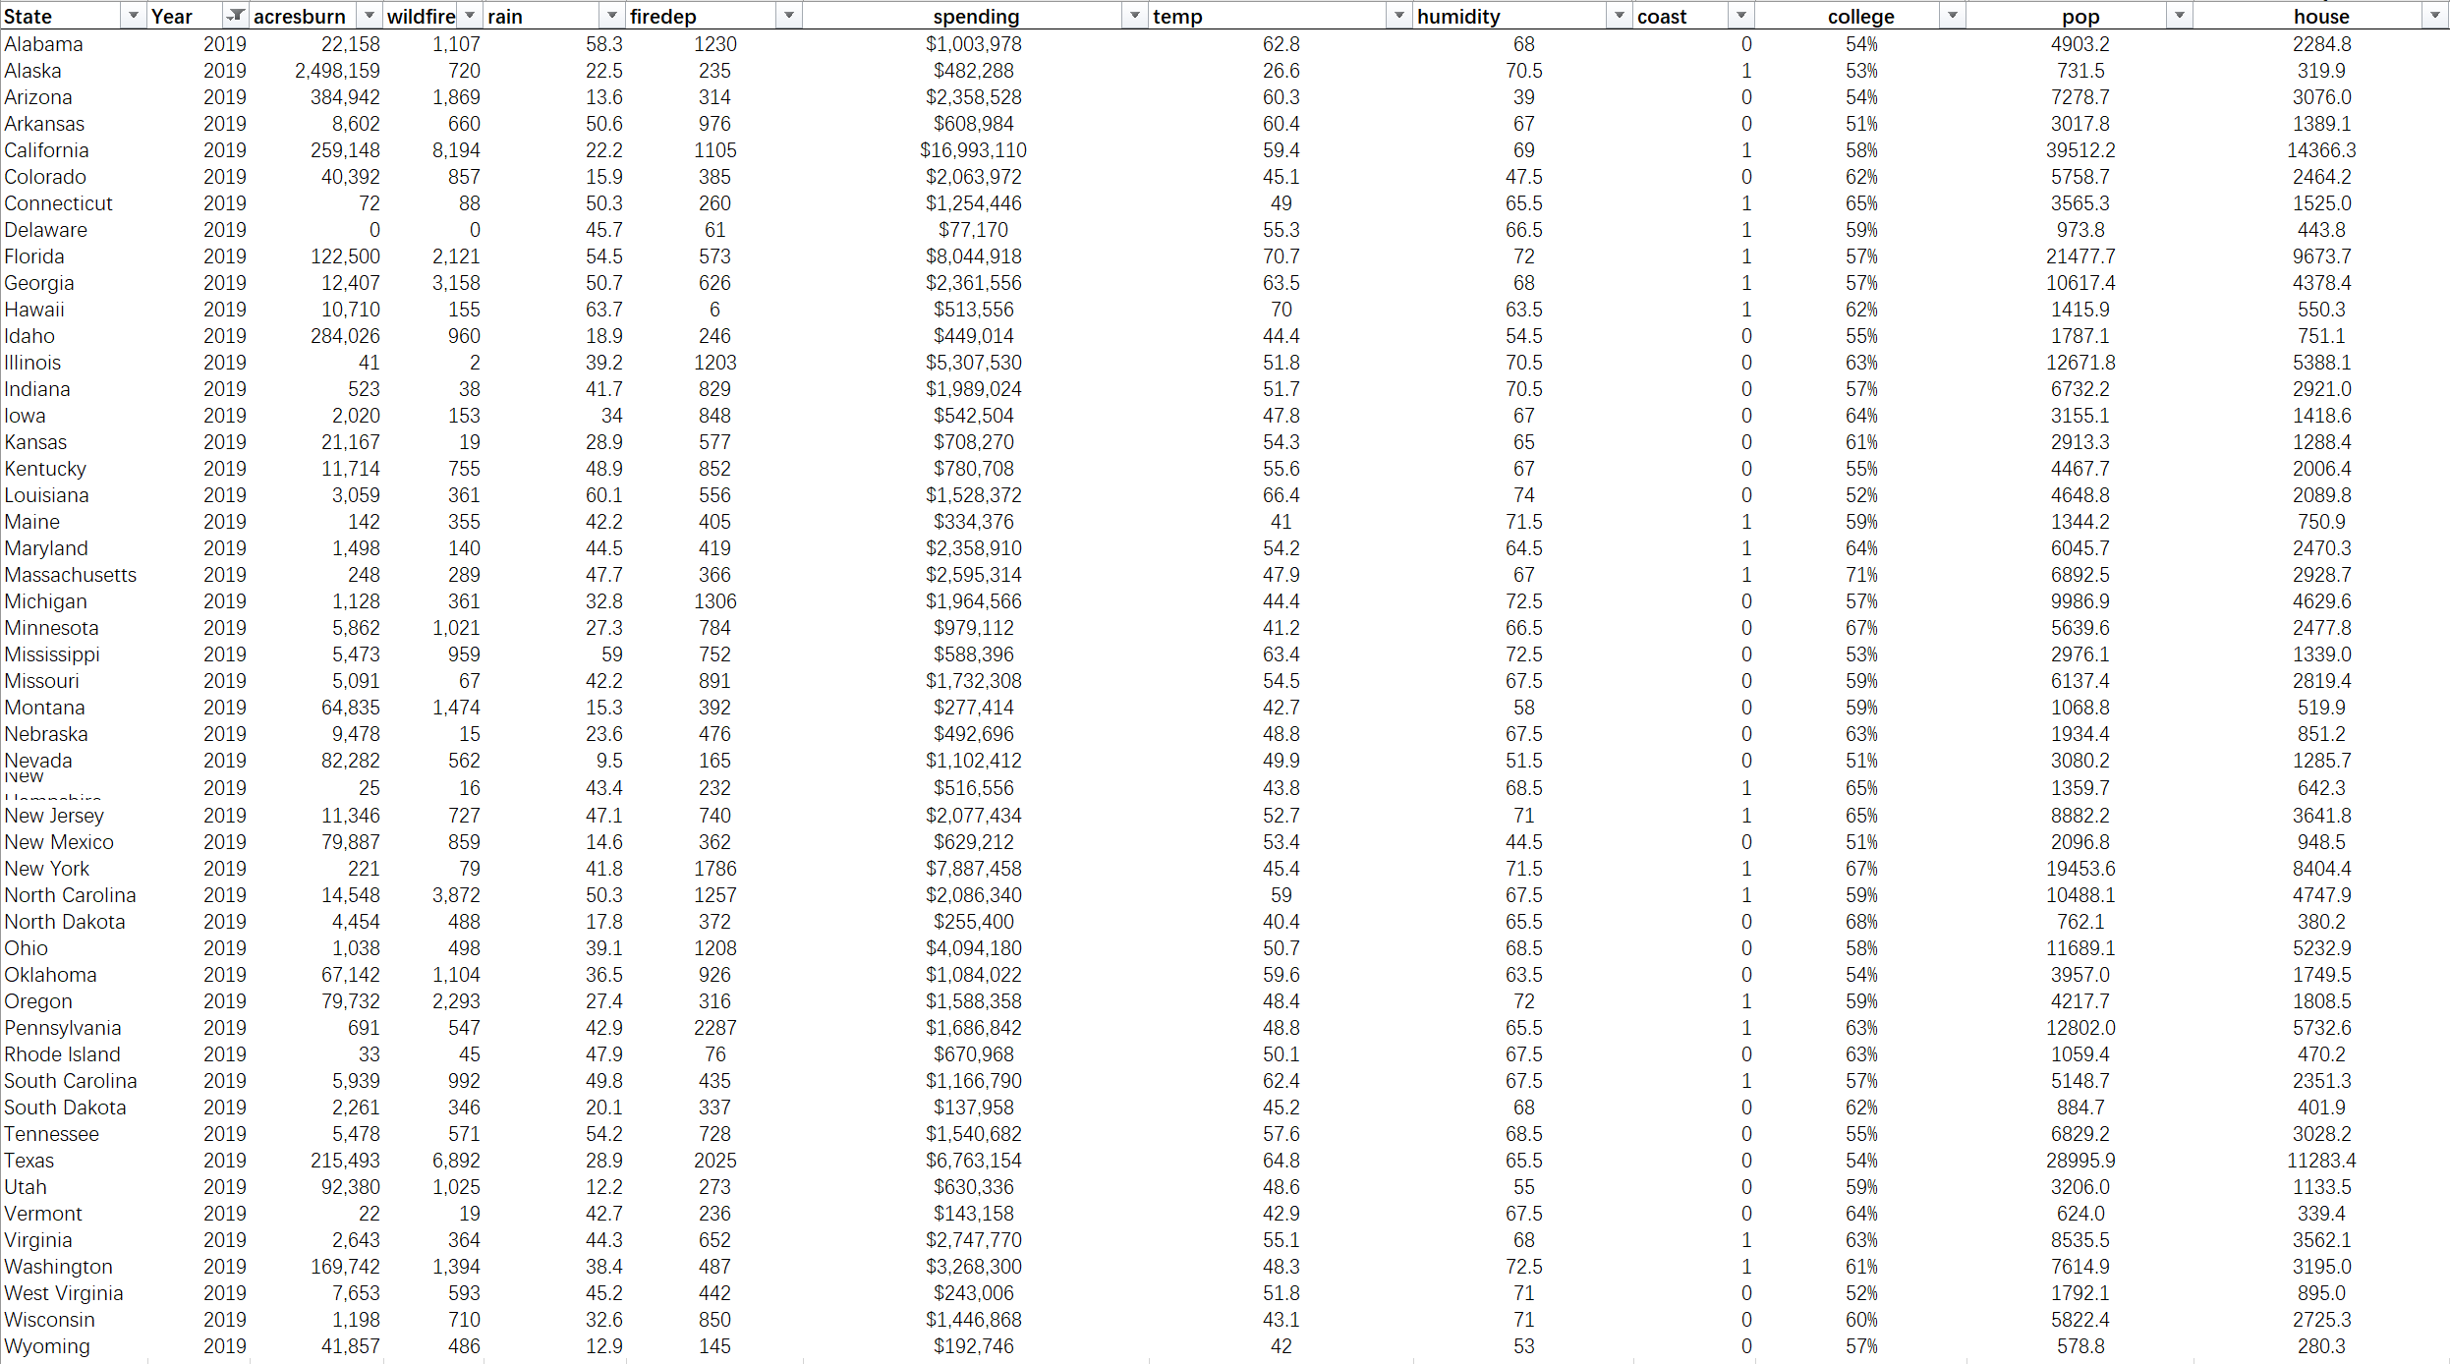

Table 4.B Data Appendix Data for the year 2010

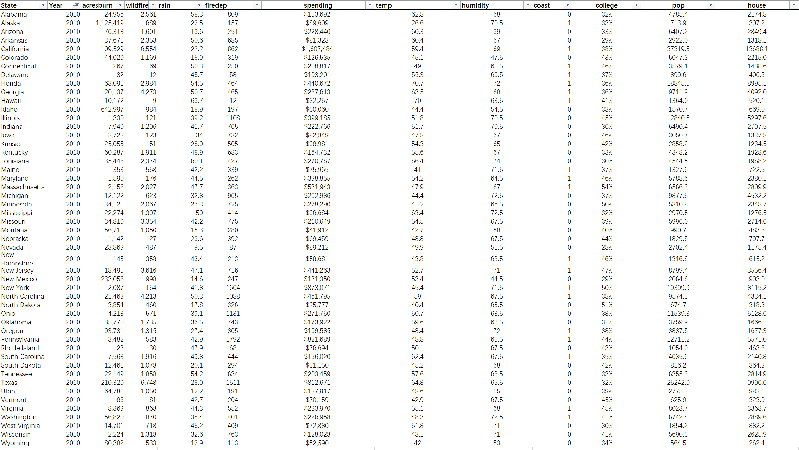

Table 4.C Data Appendix Data for the year 2000

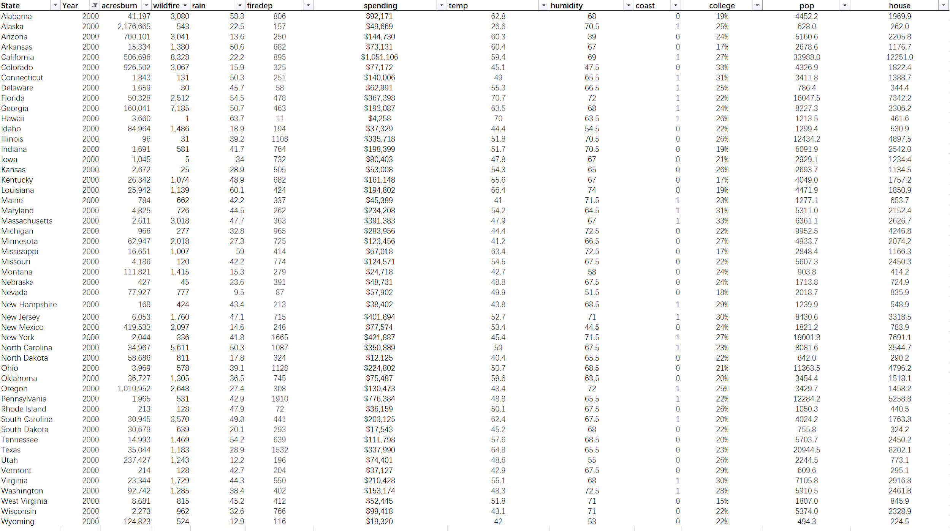

Table 6 Triangle table

